BLACK FRIDAY SALES ANALYSIS
Executive Summary & Key Findings
1. Business Objective
The objective of this analysis is to understand customer purchasing behavior, product performance, and city-level sales patterns during Black Friday. The analysis uses Excel, SQL, Python, and Power BI to identify high-value customer segments, evaluate product and demographic trends, and generate actionable insights for future Black Friday campaigns.
2. Data & Analytical Approach
Dataset: 550,068 transactions | 5,891 customers | 3,631 products
Analytical Workflow
Excel → SQL → Python → Statistical Analysis → Power BI
Key KPIs
- Total Sales
- Average Purchase per Customer
- Repeat Purchase Rate
- High-Value Customer Share
- City Contribution
- Category Performance
- These KPIs align with the project requirements.

3. Performance Snapshot
KPI | Result
Total Sales | ₹5.10B
Transactions | 550K+
Customers | 5,891
Average Purchase | ₹9.26K
Repeat Purchase Rate | 100%
High-Value Customer Share | 10%

Key Insights & Strategic Recommendations
1. Top 5 Insights
1. Strong repeat purchasing behavior
The dashboard shows a 100% repeat purchase rate, indicating that customers in the dataset made multiple transactions.
2. 26–35 is the strongest sales-driving age group
Customers aged 26–35 generate the highest overall purchase volume.
3. City Category B leads sales contribution
City Category B records the largest overall sales contribution among the three city categories.
4. Product demand is concentrated
Product Category 5 has the highest transaction volume, while Categories 1 and 5 are major contributors to purchase activity.
5. Customer demographics significantly influence purchase behavior
Statistical testing found significant differences in purchase levels by gender, age group, and city category (p < 0.001).
2. Strategic Recommendations
- Target the 26–35 segment with personalized offers and product bundles.
- Prioritize City Category B for inventory allocation and promotional campaigns.
- Promote high-performing product categories while using cross-selling to increase basket value.
- Develop differentiated campaigns for high-value customers to strengthen customer engagement

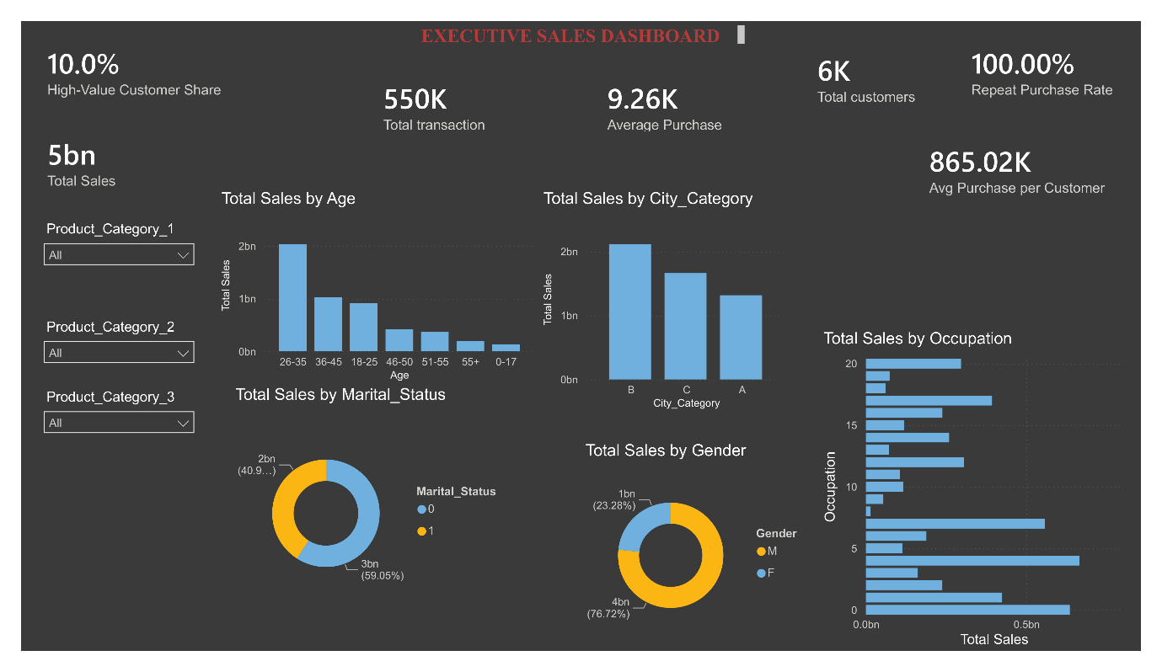
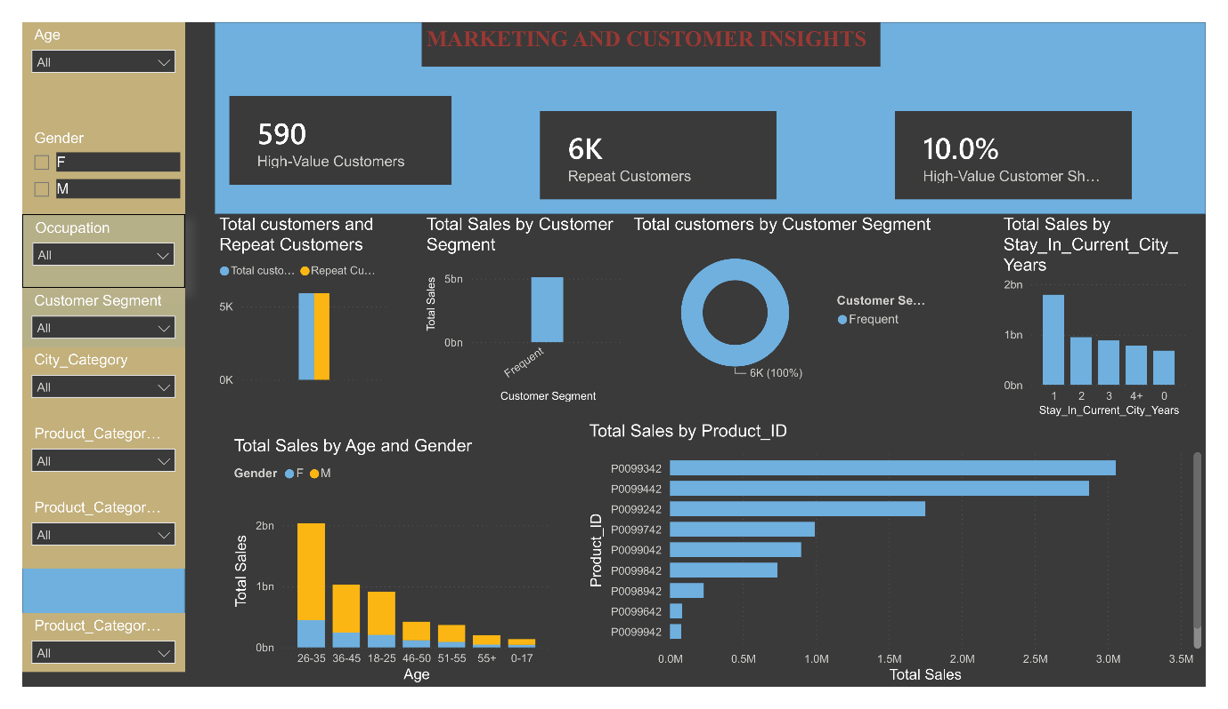
- Supporting visuals from the Power BI Executive and Marketing dashboards.

